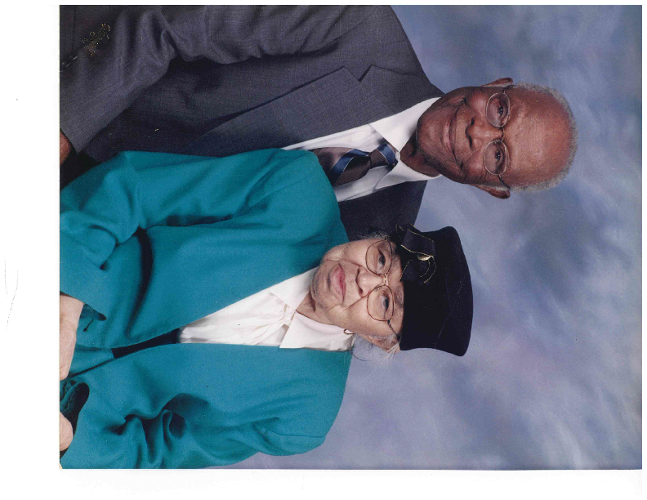
THE GEORGE AND MINNIE SNEAD
SCHOLARSHIP FOR HIGHER EDUCATION
ABOUT THE FUND

The George and Minnie Snead Scholarship Fund provides assistance to qualified students to meet mandatory fees while pursuing a degree at an accredited post-secondary school on a full-time basis.
The Fund is designed to provide financial support, through scholarship awards, to meet minimum
degree requirements for the career sought. The George and Minnie Snead scholarship is available to eligible applicants who meet the qualifications stipulated in the criteria contained in this document.
The Fund is administered by the Central Union Baptist Church.

Application Date: The deadline to submit a completed application and all supporting documentation is April 15th of the current year. Notice of award(s) will be made by June 30th of the current year. Incomplete or late applications are ineligible.

Award Amount: The amount of the scholarship award is dependent upon the availability of funds at the time of award. Once an award is made, the Fund is committed to make the payout on behalf of the student. Award(s) up to $2000 will be made annually by the Central Union Baptist Church. Scholarship awards will be issued to the school designated by the applicant. The award is divided into two allotments.

- Fall Semester: Upon submission of letter of acceptance to the college or university the student plans to attend and /or registration bill.

- Spring Semester: Evidence of good standing and continued enrollment or registration bill from college or university.

This is a scholarship program and not a ministry of kindness or benevolent function of the Church. This particular fund has no provision for “emergency” requests or circumstances arising outside of the rules set forth in the scholarship criteria.

NOTE! All awards will be paid directly to the college or university of attendance.

